System Design Document

Client Side Development

Student Name/ID: Ignesias Tan – 90052578

# Introduction

## Purpose

Portfolio website to display competency in using various languages and also relevant information regarding previous employment, projects, and contact information.

As such I have chosen to include in 4 pages as follows:

1. Summary Page
2. Previous Projects
3. Work History
4. Contact

Brief and consistent UI to communicate to the potential employer on what I can offer.

## Scope

The core of the user story is:

I would like to be able understand what the applicant is capable of.

1. I would like to know what the applicant’s intentions are
2. I would like to be able to see what the applicant’s work history is
3. I want to know what type of languages he’s worked with
4. I want his contact details
5. I want to review the layout of his website to show his competencies

## Roles & Responsibilities

**Ignesias Tan:**

* QA Analyst
* Test Manager
* Configuration Manager
* Developer
* Installation

# Solution Design

## Architecture Overview

The goal is to create a website that is able to convey to the potential employer what the applicant is capable of and what the applicant can offer.

## Site Map

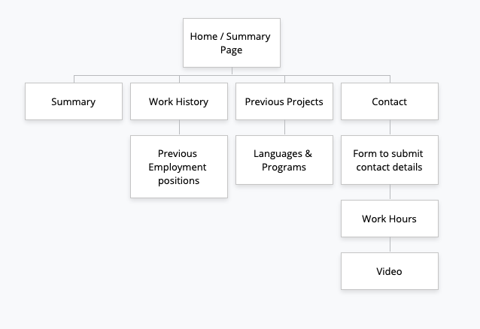

## View Design: UI

|  |  |  |  |  |  |
| --- | --- | --- | --- | --- | --- |
| **Element** | **Description** | **Mobile Device** | **Tablet** | **Computer** | **Fills User Stories** |
| **Summary** | Provides user with a summary much similar to a cover letter on what the applicant’s intentions are. | Yes | Yes | Yes | 1,5 |
| **Work History** | Lists out the applicant’s work history much like a CV. | Yes | Yes | Yes | 2,5 |
| **Previous Projects** | Summarizes the applicant’s capability in using various languages to match with what the potential employer is looking for. | Yes | Yes | Yes | 3,5 |
| **Contact** | Contact information such as an email/contact no for the potential employer to contact the applicant. | Yes | Yes | Yes | 4,5 |

## Design Considerations

### User Authentication

No authentication required

### Security

Security requirements to be included:

#### Keeping website up to date

Make sure I’m not using out of date software

#### Anti-malware software

Scan and prevent malicious attacks

#### Phishing Emails

Filter through the phishing emails that I may receive as I’m leaving my contact details available

#### Password

Have a password installed to prevent the modification of my website by hackers

### Usability

The website must be easy to understand and have a professional display.

### Portability

The app will be available on mobile, tablets, laptop/desktop devices

# Detailed Design

**Wireframe**

**Desktop/Laptop:**

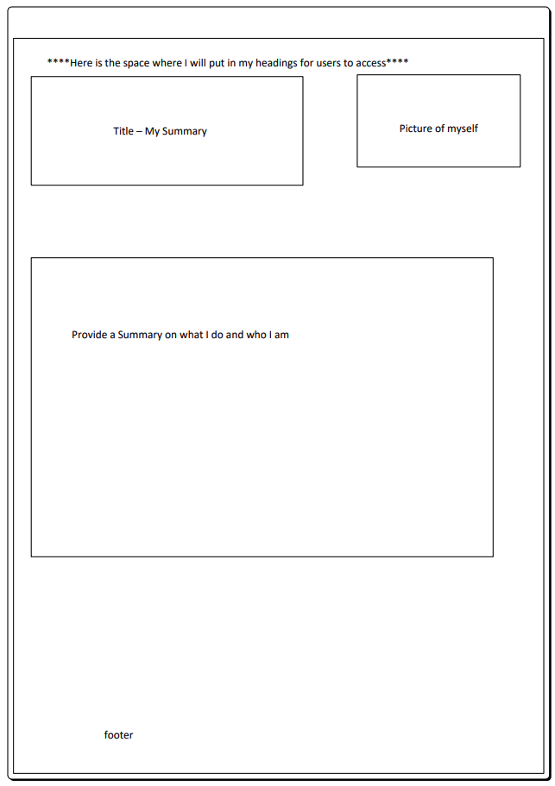

**1000px wide

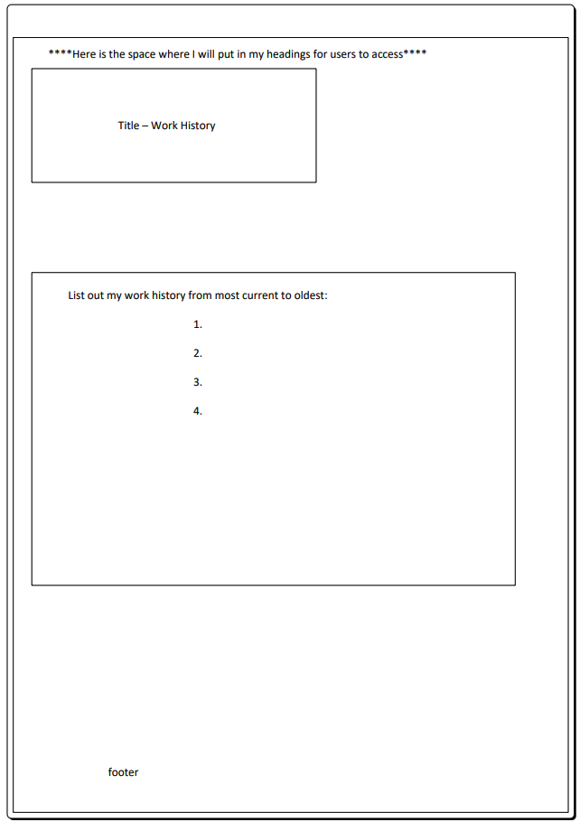

**1000px wide

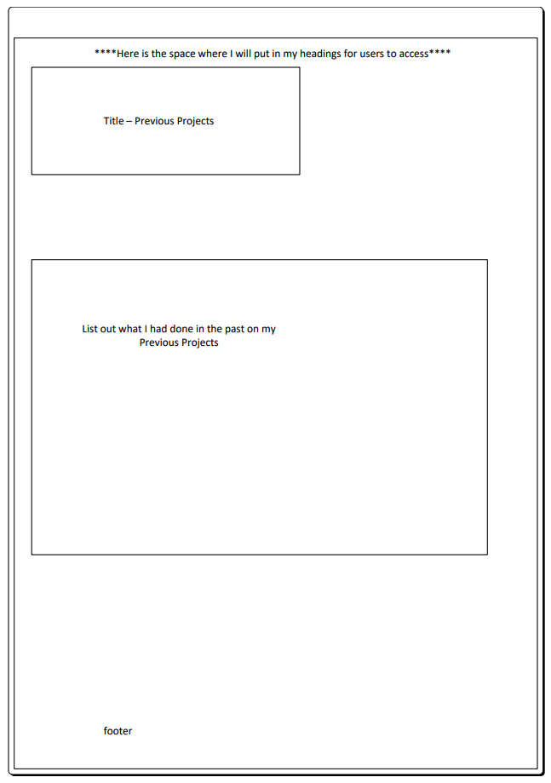

**1000px wide

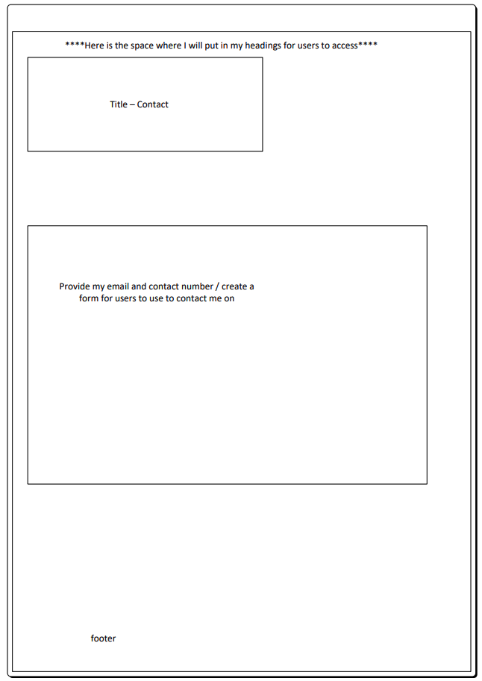

**1000px wide

**Tablet:**



825px wide**



825px wide**



825px wide**



825px wide**

**Phone:**



625px wide**



625px wide**



625px wide**



625px wide**

**Mock up**

**Desktop/laptop:**

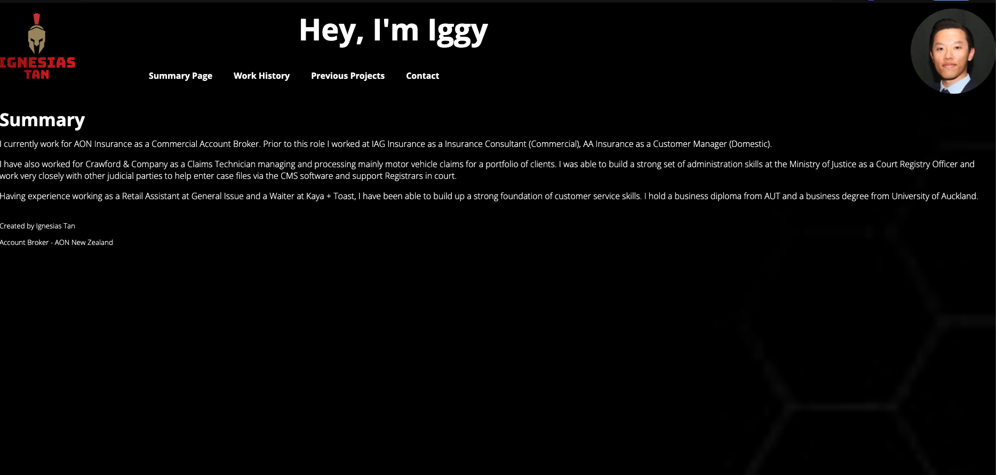

**Tablet:**

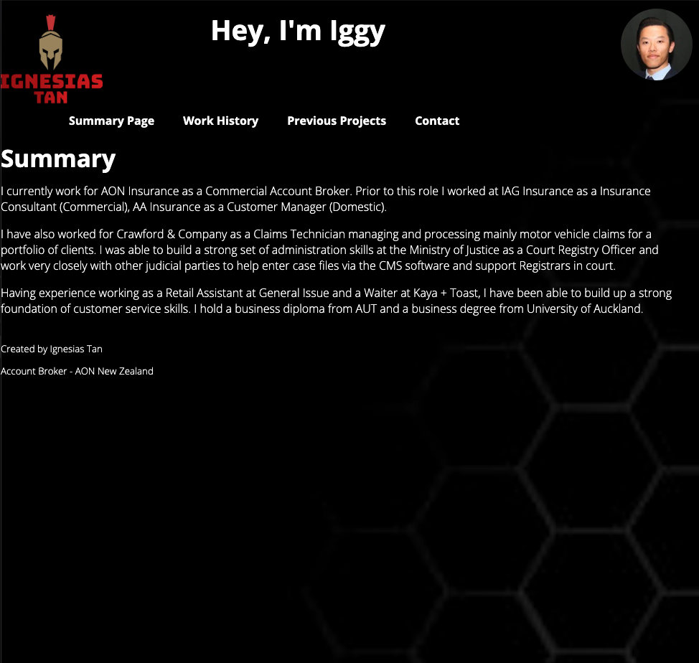

**Phone:**

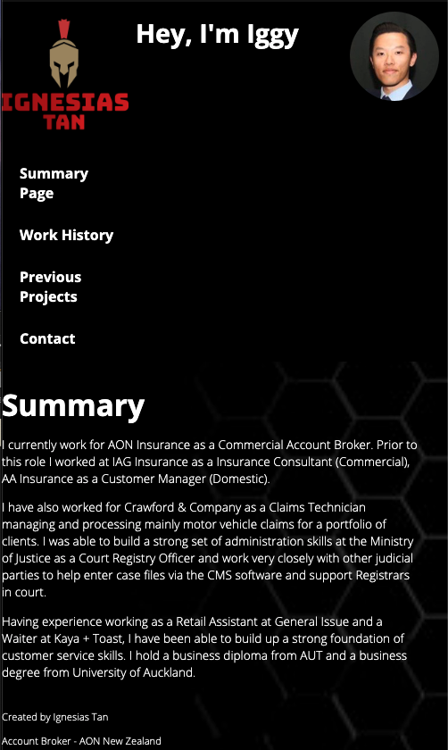

# Test Methodology

## Overview

In the development of this website I adopted an Agile approach to the project according to the instructions as noted under Project v3A.

The main reason for adopting this particular approach is because the requirements that were listed were easily broken into different components that can be dealt with incrementally.

My portfolio website acted as base template for me to edit/add elements and components so it was simply a matter of incorporating or executing the following:

1. Ensuring that the links were in working order
2. Incorporate 5 elements of DOM
3. Incorporate 2 components of React.JS
4. Ensure that a web form is included to validate user entries and a ‘Thank you” page prompt upon submission
5. Site map of website
6. Multi-device wireframes for 4 pages
7. Multi-device mock-up for 1 page

## Test Environment

Following **software’s** are required in addition to client-specific software.

1. Windows 8 and above / Mac OS 10.15.5 and above
2. Chrome, Safari, Internet Explorer, Firefox
3. Multi-device testing: Desktop/laptop, Tablet, and Phone

## Testing Plan

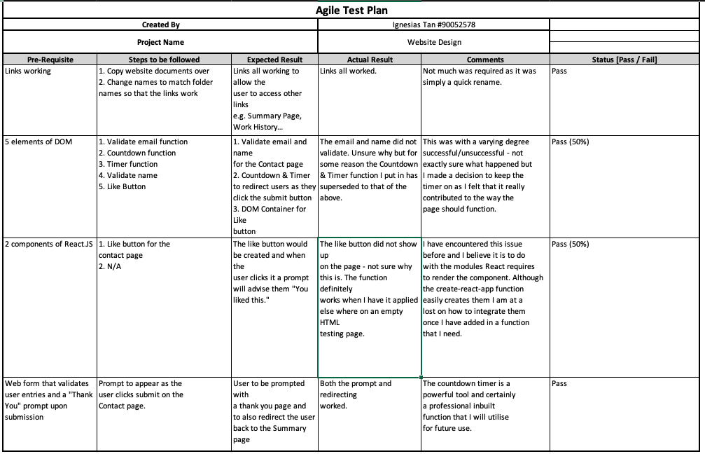

# Misc.

**All relevant HTML, CSS, and JS files are within the WebsiteDesign folder

**The Wireframe.vsdx file is left in there as reference if you wish to use Visio to review it. There is a screenshot copy in this document as well